
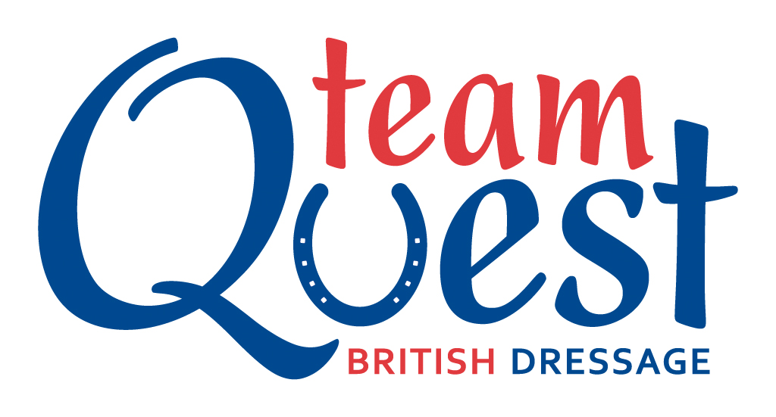
NETHERTON EQUESTRIAN
Aberargie, Bridge of Earn, PH2 9NE

Unaff DRESSAGE
Incl RoR Regional Points, Veteran and NPS Qualifiers
and My and Team Quest

Sunday 2nd December

Entry fee - £12.00 per class.

Class 1 BD Intro B (2009) can be on the lead rein, includes Veteran Qualifier.
Class 1 MQ BD Intro B (2009)
Class 2 BD Intro C (2016) can be on the lead rein, includes Veteran Qualifier.
Class 2 TQ BD Intro C (2016)
Class 3 BD Prelim 7 (2002) includes Veteran Qualifier and NPS Qualifiers
Class 3 MQ BD Prelim 7 (2002)
Class 4 BD Prelim 13 (2006) includes Veteran Qualifier
Class 4 TQ BD Prelim 13 (2006)
Class 5 BD Novice 24 (2010) includes Veteran Qualifier and NPS Qualifiers
Class 5 MQ BD Novice 24 (2010)
Class 6 BD Novice 34 (2009) includes Veteran Qualifier
Class 6 TQ BD Novice 34 (2009)
Class 7 PYO Level
BD Elem 44 (2002) includes Veteran Qualifier.
BD Medium 63 (2002)
BD Advance Medium 90 (2012)
Class 8 PYO Level
BD Elem 49 (2009) includes Veteran Qualifier.
BD Medium 71 (2002)

Classes may be split or combined depending on entries. Please include your age group as we may split classes into Junior (Under 18) and Senior (18 and over) Sections.

Warmup and competition in mixture of indoor/outdoor arenas.

All classes to be run under BD rules, so please no martingales and only BD legal bits and nosebands allowed.

For details on NPS Qualifiers please go to www.nationalponysociety.com/dressage/

All Classes include R0R Regional Points - Open to registered ROR and non-registered ex- racehorses but on qualifying non- registered horses must register with the ROR (Retraining of Racehorses) which can be done on-line and is free. See website www.ror.org.uk.

Classes 1-8 include Scottish Veteran Qualifiers. To qualify horses must be 15 years and over. There will be two sections: Pre Veteran 15yrs-19yrs and Veteran 20yrs+. There will also be a separate qualifying section where the combined age of horse and rider is 60 years and above. You do not need to be a member of Scottish Veteran Dressage to qualify but you will be required to join to compete in the finals. All combinations that gain 58% or over at each test level qualify for the final. Horses can only qualify at two consecutive levels eg Intro and Prelim or Nov and Elem. Upon qualification riders will be given their qualifying slip and rosette. The rider then has to register their qualification with Scottish Veteran Dressage. Scottish Veteran Dressage is run under BD rules. For further details please contact Hannah Burns 07928590090.

Any questions please get in touch with Joanna Wilkie on 0780 1418681, email info@nethertonequestrian.co.uk, or message on facebook to “Netherton Equestrian”.

Separate entry forms are available on the website for Team and My Quest classes.

Entries close Thursday 29th November
Any cheques made payable to J. Wilkie.
***You enter online at www.equoevents.com

****** Times available on Friday 30th November on Equo Events or our website www.nethertonequestrian.co.uk

