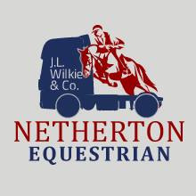
Netherton Equestrian Livery Application
Please continue on extra paper if required
Your Name

Address

Tel No

Emergency Contact Name

Emergency Contact Number

E-mail

Horse Name

Horse Height

Horse Breed

Identifying Marks/ freeze brand/microchip
(Please enclose a copy of the passport)

Vet & Contact

Any health issues with your horse or at current yard

Date of last vaccination

Date of Last Wormed

Type of livery required

Personal Specifications

Reason for leaving current yard

